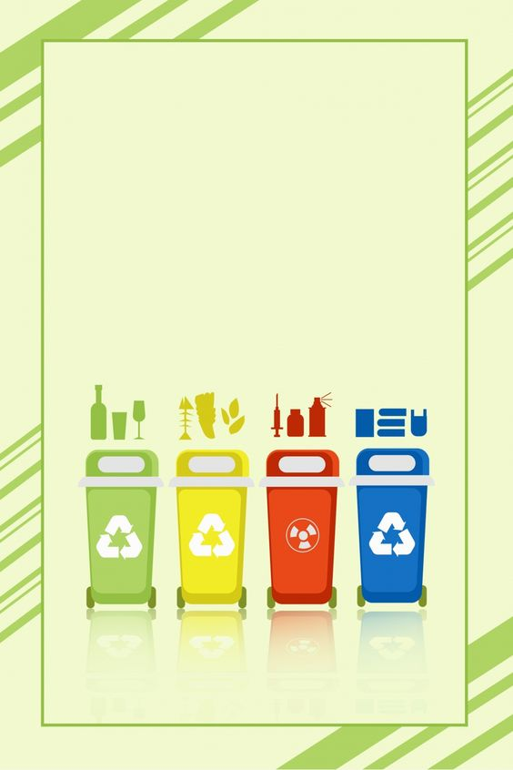

Town of Johnstown

CLEAN UP DAYS

Help Keep Our Town Clean

Thursday May 2nd 11am - 6pm

Friday May 3rd  11am - 6 pm

Saturday May 4th 7am - 1pm

**WHERE: Town Highway Garage at 237 County Highway 101, Gloversville**.

UNACCEPTABLE ITEMS: ACCEPTABLE ITEMS:

HAZARDOUS WASTE FURNITURE/APPLIANCES

PAINT HOME IMPROVEMENT MATERIALS

BATTERIES BULK ITEMS

MOTOR OIL MISCELLANIOUS JUNK

RECYCLABLES TIRES(NO CHARGE / MUST BE OFF RIM)

HOUSEHOLD GARBAGE LIMIT 4 PER RESIDENT

TOWN RESIDENTS ONLY! NO CONTRACTORS OR DUMP TRUCKS!

FOR FURTHER INFORMATION PLEASE CALL THE TOWN CLERK AT 518-762-7070 OR

THE FULTON COUNTY DEPARTMENT OF SOLID WASTE AT 518-736-5501.